Arctic Ocean

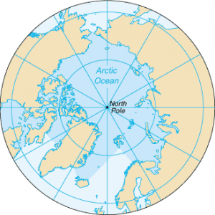

arcticocean.png

1. Arctic Cod: Arctic cod, also known as polar cod, are a keystone species in the Arctic Ocean's food web.

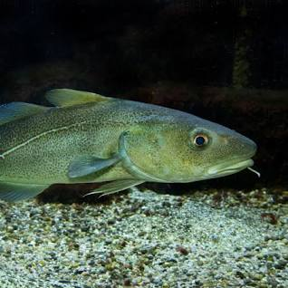

arcticcod_creaturesinarcticocean.png

Arctic char is a cold-water fish species that is well adapted to the Arctic's frigid waters

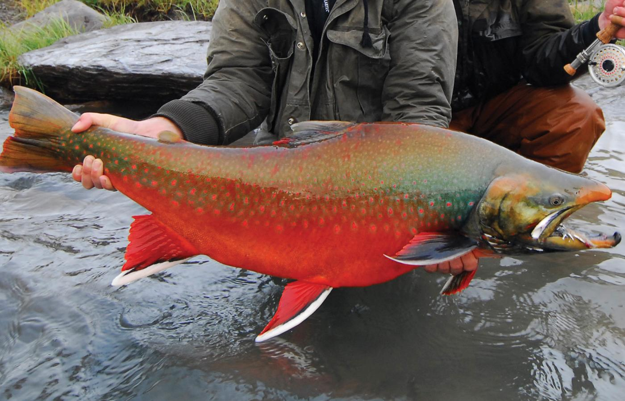

arcticchar_creaturesinarcticocean.png

Arctic Jellyfish: Several species of jellyfish, such as the lion's mane jellyfish, are adapted to the cold waters of the Arctic Ocean.

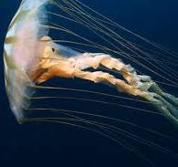

arcticjellyfish_creaturesinarcticocean.png